Gauntlet User Manual

Welcome to Gauntlet! Upon startup, you will be greeted by this screen:

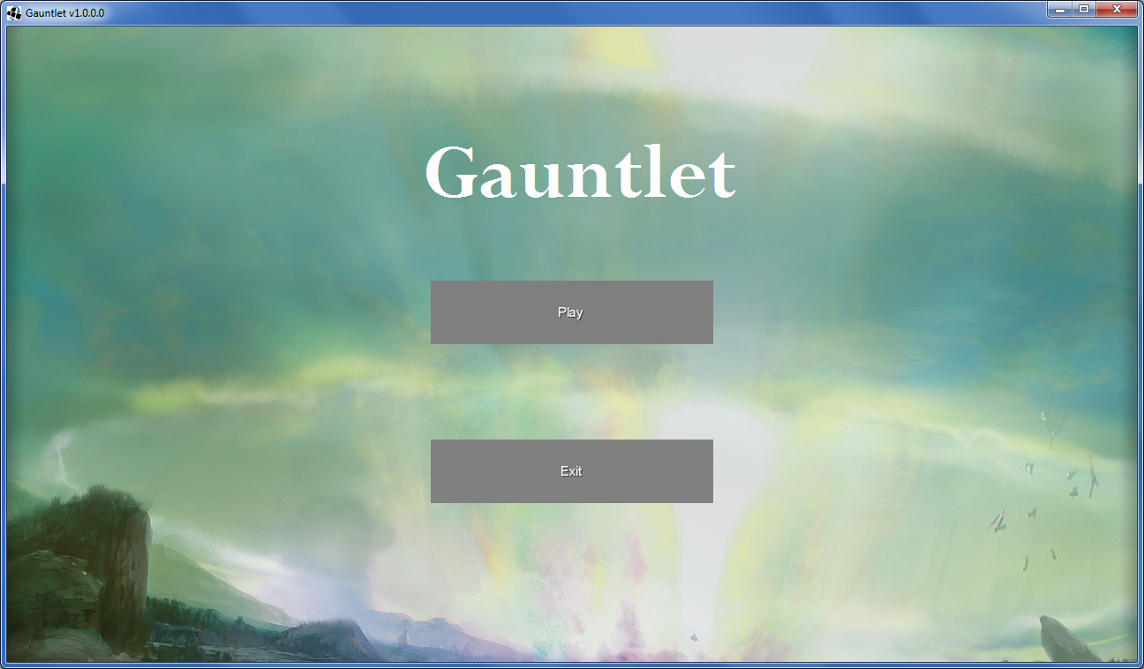

Click the exit button to exit the application, and click the play button to play the game.

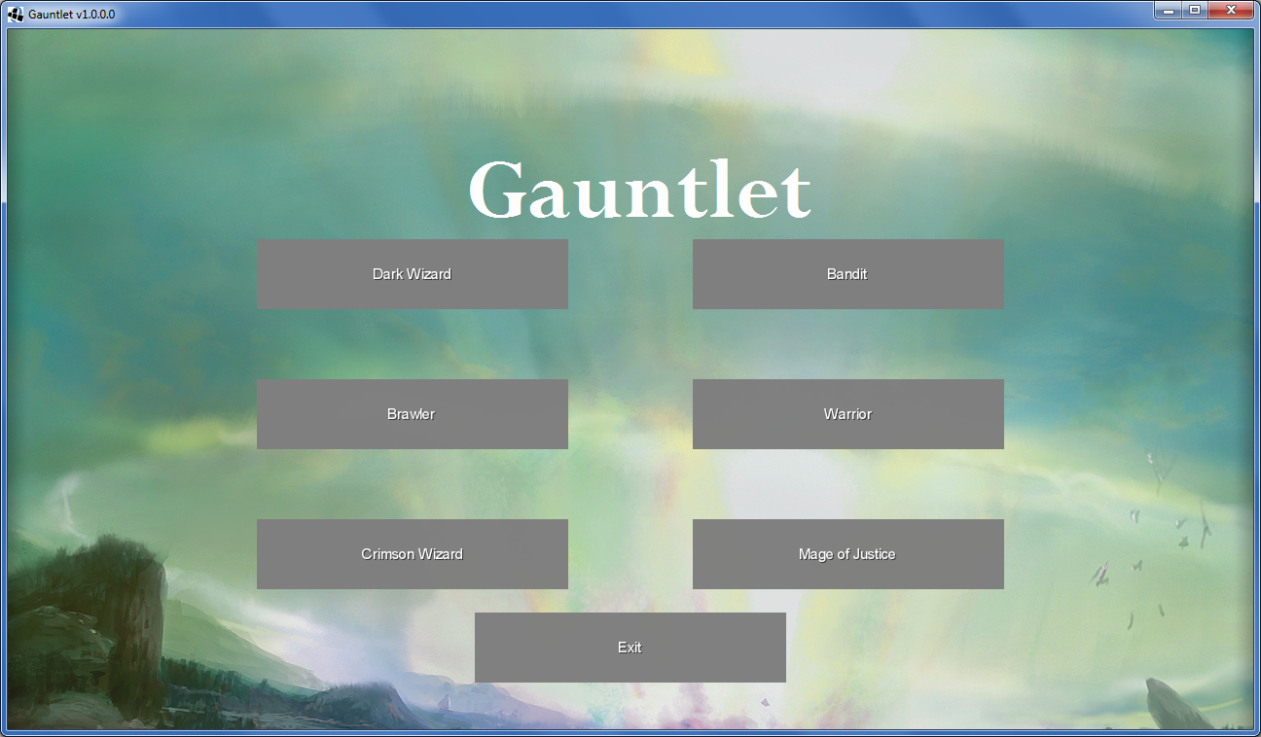

When you click on the play button, this screen appears. Here, you can choose between six classes to play as. These classes differ in cosmetic appearance only. Click on the class you want to play as and the game will start. Clicking the exit button will exit the game, as usual.

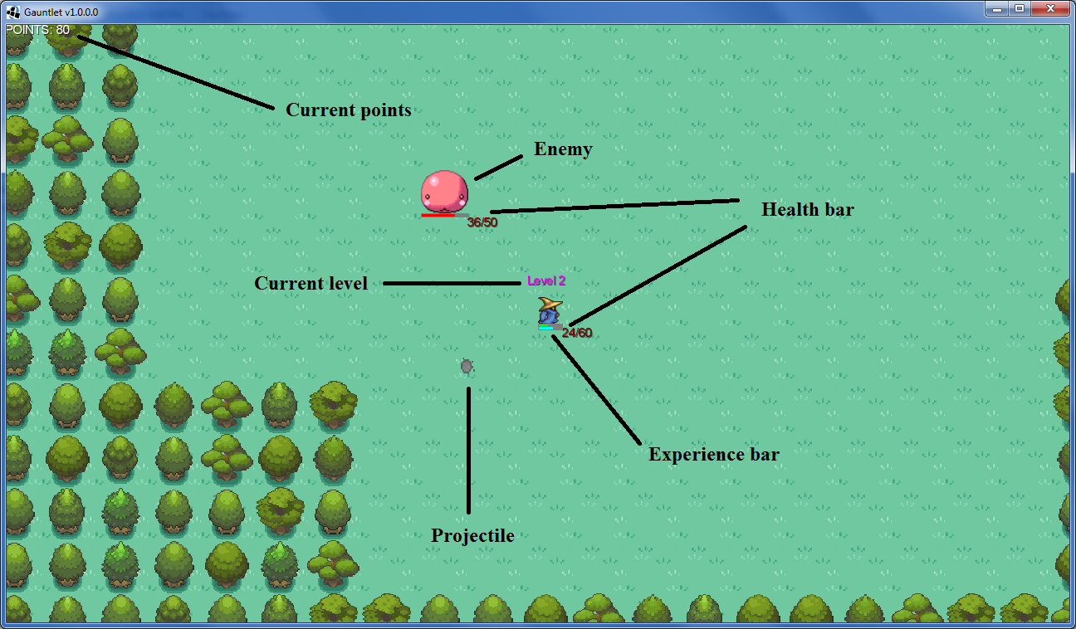

This is the gameplay screen. In the top left are the number of points you have earned so far. The red blob is one of the many enemies that you will face in the game. Both you and enemies are able to shoot projectiles. Whenever a projectile strikes an enemy or you, the projectile will deal damage. The amount of damage taken is represented by a health bar; enemies have a red health bar and you have a green health bar. When an enemy runs out of health, the enemy dies. Similarly, when you run out of health, you die and lose the game. Your current level is displayed above you. The higher the level, the more health you have and the more damage you deal. However, it gets progressively harder to level up, and a higher level will cause more enemies to spawn, so be careful. You increase in level by killing enemies and gaining experience for doing so. The experience bar is a visual indicator of how much experience you need until the next level.

Controls:

W – move up

A – move left

S – move down

D – move right

Mouse – aim

LMB – shoot

ESC – pause

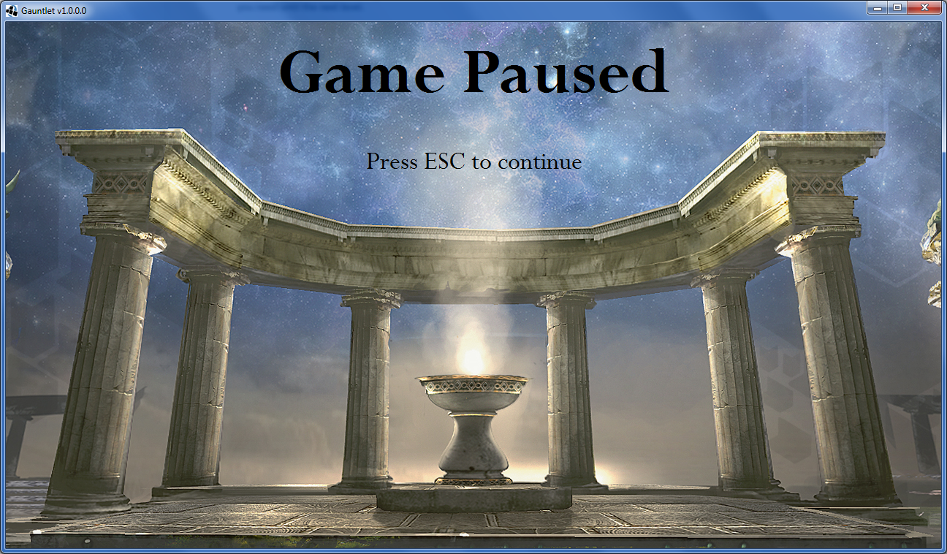

Pressing ESC will open the pause menu. Pressing ESC again will redisplay the gameplay screen, but gameplay will remain frozen for another two seconds so you can ready yourself.

Good luck!